INFOSYS MILESTONE 4
HotelRevAI-AI Driven Revenue Analysis for Hotels

Abstract
The hospitality industry generates large volumes of booking data that can be used to understand customer behavior, revenue patterns, and hotel performance. However, raw data collected from different sources is often unstructured and requires proper preparation before meaningful analysis can be performed. This project focuses on analyzing hotel booking data and transforming it into a structured analytical model using Power BI. The main objective of the project is to clean and prepare the raw data, transform it into an organized format, and develop interactive dashboards that provide insights into hotel revenue, bookings, customer behavior, and overall hotel performance. The dataset used in this project was collected from an open-source repository and processed using Power Query for cleaning and transformation. Data modeling techniques and DAX calculations were then applied to generate key performance indicators. Finally, multiple dashboards were created to visually represent the insights obtained from the data. The project demonstrates how raw hospitality data can be converted into meaningful business intelligence solutions that support data-driven decision making.

Introduction:
Hotels and hospitality businesses depend heavily on booking data to understand their customers and improve revenue management strategies. Large amounts of booking information are generated every day, including details about guests, stay duration, booking channels, pricing, and reservation status. When properly analyzed, this data can provide valuable insights that help hotels improve their services, optimize pricing strategies, and increase revenue.
However, raw booking data is often complex and contains inconsistencies such as missing values, unnecessary columns, incorrect data formats, and redundant attributes. Without proper cleaning and preparation, it becomes difficult to perform accurate analysis. Therefore, data preprocessing plays a critical role in transforming raw datasets into structured and reliable information sources.
The objective of this project is to analyze hotel booking data using Power BI and convert it into a comprehensive analytical solution. The project involves several stages including data collection, data cleaning, transformation, modeling, calculation of important metrics, and development of interactive dashboards. These dashboards help visualize revenue trends, booking patterns, customer behavior, and hotel performance metrics in a clear and interactive manner.
Through this project, raw hotel booking data is converted into a meaningful business intelligence system that can support strategic decision making in the hospitality industry.

Data Collection
The dataset used for this project was obtained from an open-source repository containing hotel booking records. The dataset includes booking information for multiple years and contains various attributes such as hotel type, arrival date, number of guests, stay duration, booking channels, reservation status, and pricing information.
The data contains records for both city hotels and resort hotels and provides information about guest composition, booking patterns, and stay duration. Since the dataset was obtained as raw data, it contained several columns that required preprocessing before analysis could be performed.
After collecting the dataset, it was imported into Power BI where the entire data preparation and analysis process was carried out.

Data Cleaning and Transformation
Once the dataset was loaded into Power BI, the Power Query Editor was used to clean and transform the data. Raw datasets often contain redundant information, missing values, and inconsistent data types, which must be corrected before performing analysis.
The first step involved reviewing all columns in the dataset to understand their structure and relevance. Columns that were not necessary for the analysis were removed in order to simplify the dataset and reduce complexity.
Next, several columns were transformed to ensure they had the correct data types. Date-related columns such as arrival date and reservation status date were converted into proper date formats so that time-based analysis could be performed accurately.
Guest-related information was also reorganized. The dataset originally contained separate columns for adults, children, and babies. These columns were combined to create a new column representing the total number of guests for each booking. This transformation simplified the analysis and allowed a clearer understanding of guest composition.
Similarly, the dataset contained separate columns representing weekday stay nights and weekend stay nights. These columns were combined to create a single column representing the total number of nights stayed by guests.
Revenue-related values were verified and formatted properly. The revenue calculation was aligned with the pricing column so that meaningful financial analysis could be performed.
Through these transformations, the dataset was converted from a raw format into a structured and analysis-ready dataset.

Data Modeling and Analytical Preparation
After cleaning and transforming the dataset, the next step involved preparing the data model for analysis. Data modeling helps organize the dataset in a way that allows efficient filtering, calculations, and visualization.
Year-based analysis was enabled by separating the data according to arrival year. This allowed comparisons between different years and helped identify booking trends over time.
To support analytical calculations, DAX measures were created within Power BI. These measures were designed to calculate key performance indicators that would be used throughout the dashboards. Some of the important metrics calculated included total revenue, total bookings, total guests, and average revenue values.
DAX measures allow the dashboards to update dynamically whenever filters or slicers are applied. This ensures that the visualizations remain interactive and reflect real-time insights from the dataset.
With the data cleaned, transformed, and modeled, the dataset was ready for visualization and dashboard creation.

DashBoard Development
To effectively analyze hotel booking and revenue patterns, interactive dashboards were developed using Microsoft Power BI Desktop. The objective of the dashboard development was to transform the processed dataset into meaningful visual insights that enable easy understanding of hotel performance, customer behavior, booking trends, and revenue impact.
The dashboards were designed using a structured layout and consistent visual theme, ensuring that the visuals collectively tell a clear analytical story about the hotel’s operations. Each dashboard focuses on a specific analytical perspective of the dataset.
Four dashboards were created to represent different aspects of hotel data analysis.
DashBoard1: Hotel Performance Summary Dashboard
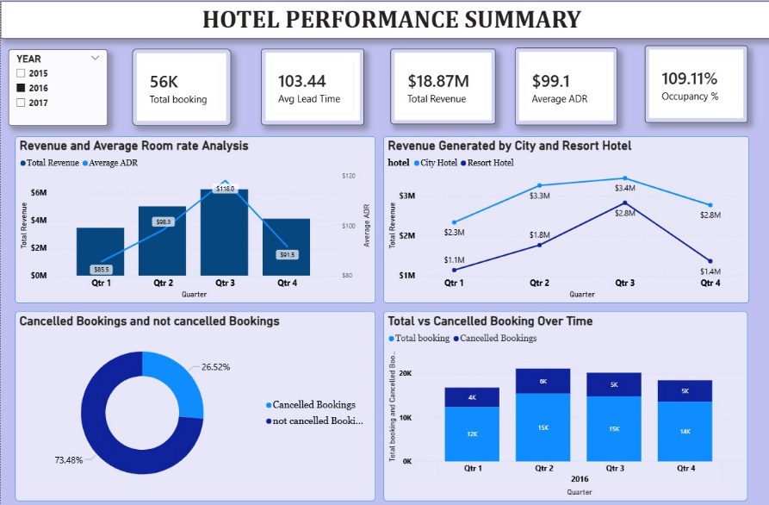
The Hotel Performance Summary Dashboard provides an overall snapshot of the hotel's operational performance. This dashboard highlights key performance indicators that help management quickly understand the hotel’s financial and operational status.
The dashboard includes important KPIs such as:
- Total Bookings
- Average Lead Time
- Total Revenue
- Average Daily Rate (ADR)
- Occupancy Rate
In addition to KPIs, analytical charts are used to evaluate revenue trends, cancellation patterns, and hotel type performance.
Key visualizations included in this dashboard:
- Revenue and Average Room Rate analysis across quarters
- Revenue generated by City Hotels vs Resort Hotels
- Distribution of Cancelled vs Non-Cancelled bookings
- Comparison of Total bookings and Cancelled bookings over time
This dashboard enables stakeholders to quickly evaluate the overall performance and booking patterns of the hotel business.
DashBoard 2: Guest Profiling and Market Segmentation Dashboard
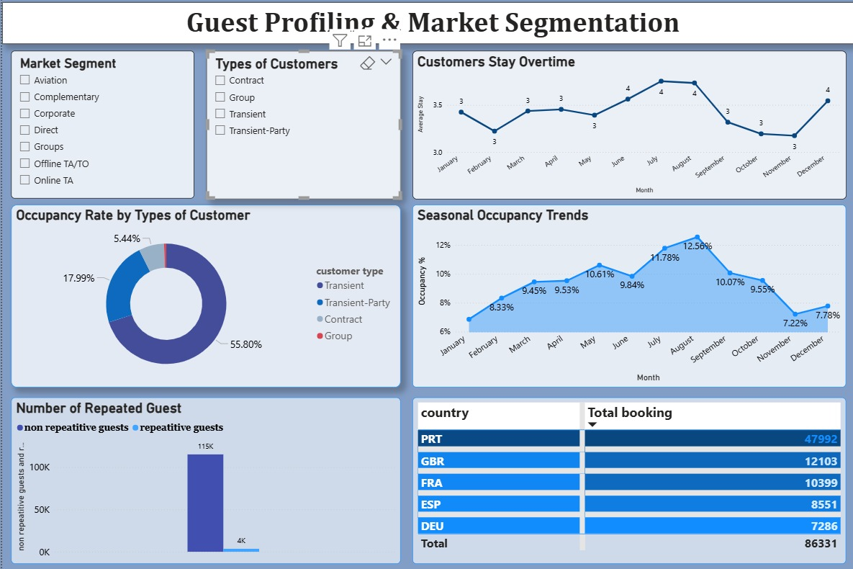
The Guest Profiling and Market Segmentation Dashboard focuses on understanding customer demographics, market segments, and guest behavior patterns. This dashboard helps identify the types of customers contributing to hotel bookings and their stay behavior.
Filters and slicers were incorporated to allow dynamic analysis by:
- Market Segment
- Customer Type
- Booking categories
Major insights represented in this dashboard include:
- Average stay duration of customers over time
- Occupancy distribution by customer type
- Seasonal occupancy trends across months
- Number of repeated vs non-repeated guests
- Total bookings by country
This dashboard helps hotel management understand customer preferences, segmentation patterns, and guest retention behavior, enabling targeted marketing and better service strategies.
DashBoard 3: Booking Behavior and Stay Preferences Dashboard
The Booking Behavior and Stay Preferences Dashboard analyzes guest booking patterns and stay characteristics. This dashboard provides insights into guest preferences regarding meal plans, length of stay, and special requests.
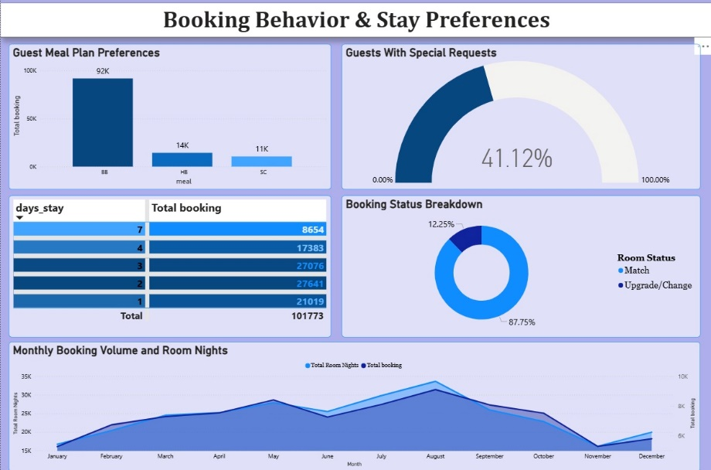
The Booking Behavior and Stay Preferences Dashboard analyzes guest booking patterns and stay characteristics. This dashboard provides insights into guest preferences regarding meal plans, length of stay, and special requests.
Key visualizations included in this dashboard:
- Guest meal plan preferences (BB, HB, SC)
- Percentage of guests with special requests
- Distribution of bookings based on days of stay
- Booking status breakdown
- Monthly booking volume and total room nights
This dashboard helps hotel management identify seasonal booking demand, guest service requirements, and preferred stay patterns, which can assist in improving operational planning and customer experience.

DashBoard 4: Revenue and Cancellation Analysis Dashboard
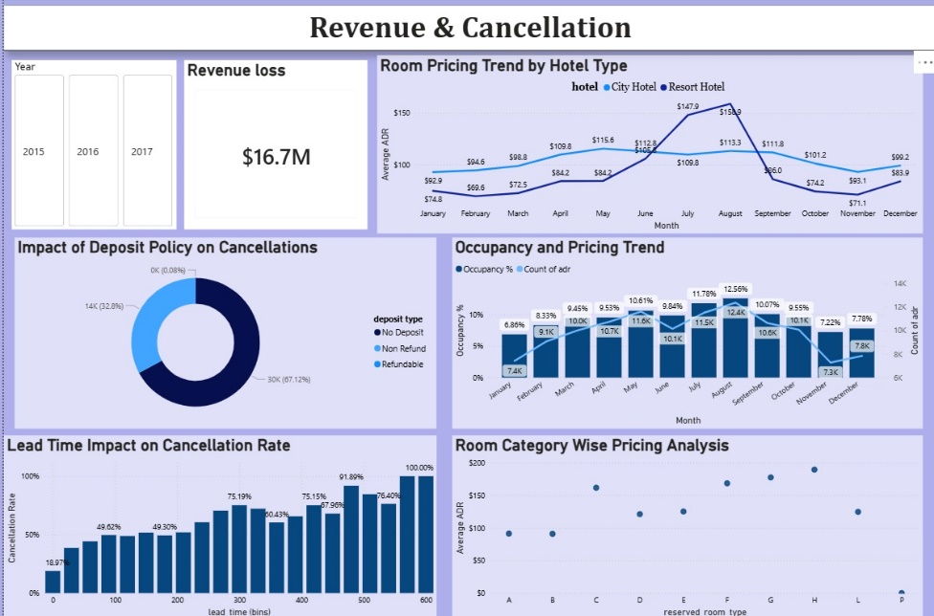
The Revenue and Cancellation Analysis Dashboard focuses on understanding the financial impact of cancellations and pricing patterns across hotel types.
This dashboard includes:
- Total revenue loss due to cancellations
- Pricing trends between City and Resort hotels
- Impact of deposit policies on cancellations
- Occupancy and pricing trends across months
- Effect of lead time on cancellation rates
- Room category wise pricing analysis
The insights generated through this dashboard help identify factors influencing cancellations, pricing strategies, and revenue loss, enabling hotel management to optimize pricing and reservation policies.

Conclusion
This project successfully demonstrates how raw hotel booking data can be transformed into a meaningful business intelligence solution. The process began with collecting a raw dataset and performing detailed data cleaning and transformation to ensure data accuracy and consistency. Unnecessary columns were removed, important attributes were reorganized, and new analytical columns were created to improve the structure of the dataset.
Once the data preparation was completed, the dataset was modeled and enhanced with DAX calculations to generate important performance metrics. These calculations enabled dynamic analysis and supported the development of interactive dashboards.
The final dashboards provide clear insights into hotel revenue, booking behavior, customer stay patterns, and overall hotel performance. By visualizing the data through interactive charts and metrics, the project demonstrates how business intelligence tools like Power BI can convert complex datasets into valuable insights.
Overall, this work establishes a strong analytical foundation that can support further development in future stages, such as predictive analytics and AI-driven revenue forecasting. The project highlights the importance of data preparation, modeling, and visualization in transforming raw data into actionable knowledge for decision-making.

PRESENTED BY:
N.MOKSHITHA.

